Sayana Press

Step 1: Choose and prepare where to inject
Select the area of your skin for the injection – it should either be your stomach away from your belly button (navel) or the front of your upper thigh, avoiding any bony areas and any part of your skin that has scars. The white areas in the picture show where you can self-inject Sayana Press.
Whoever is injecting the Sayana Press should wash her (or his) hands with soap and water then clean your skin where you will use the injection – preferably with cotton or a clean cloth soaked in clean water or with an alcohol pad. If you do not have alcohol, soap and clean water will be fine. Let the cleaned areas air dry (do not use a towel to dry off).

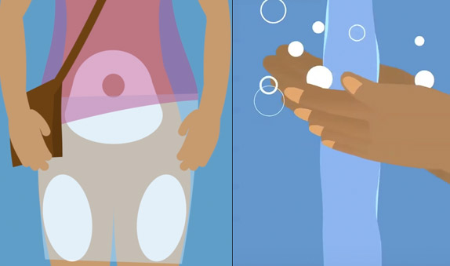

Step 2: Prepare the medicine
Make sure you have a Sayana Press pouch ready, and that it is not damaged. Check the pouch to make sure the Sayana Press injection has not expired and that it is room temperature.
Open the Sayana Press pouch and take out the injector. Look at it closely and make sure that there is a needle shield over the needle, and there is no medicine leaking from the reservoir. There should also be a gap between the needle shield and the port. If there is no needle shield or gap, or if there is damage to the reservoir, discard the Sayana Press and use a new one.
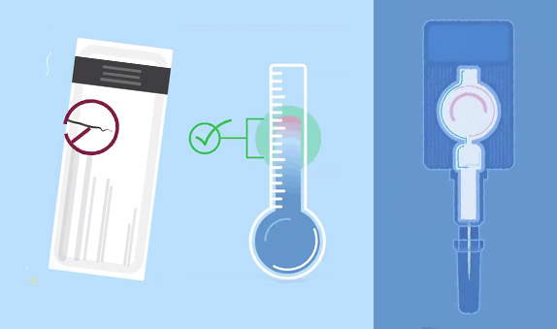

Step 3: Mixing the medicine
Hold the device by the port and shake it well for 30 seconds to get an even white or off-white liquid.
If the liquid in the reservoir does not mix well discard the Sayana Press and use a new one.
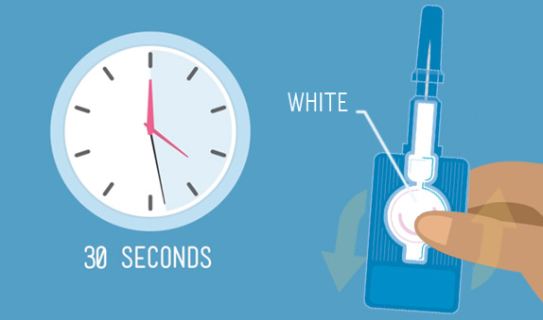

Step 4: Prepare the injection
Hold the injector firmly by the port with one hand and hold the needle shield with the other hand, then push the needle shield towards the port to close the gap. You should hear a quiet popping noise similar to the clicking sound of covering a pen with a cap.
Once you have closed the gap, you can remove the needle shield. The injection is now activated and should be held with the needle facing upwards to avoid spillage.
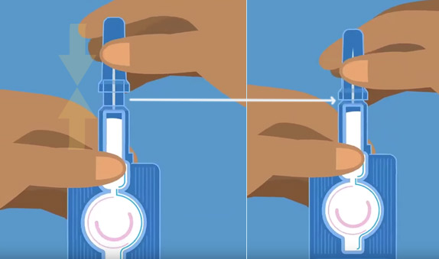

Step 5: Injecting the dose
With one hand, pinch or pull the area of your skin where you want to inject Sayana Press. With the other hand, hold on to the port of the injector, then insert the needle into the pinched skin at a downward angle until the port touches the skin completely.
Next, press the reservoir firmly between thumb and forefinger. Squeeze the reservoir slowly to inject the medicine. This should take about 5 to 7 seconds. You will probably see a little bit of liquid left in the reservoir after the reservoir has collapsed, and this is normal.
After injecting the dose, gently pull the needle out of the skin, and let go of the pinched skin. You can press on the injection area with cotton ball or clean cloth but do not massage or rub the injection site.
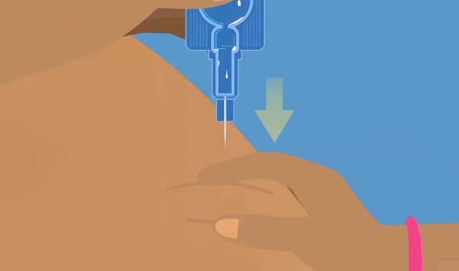

Step 6: Dispose used Sayana Press
Put the used Sayana Press into a container with a lid, such as a sharps container, or an old jar or bottle that has a wide neck and cover. Keep it away from children and animals, and do not let other people touch the needles. Throw away the container as instructed by the health worker who gave you the Sayana Press or follow local guidelines for disposal of sharps or used injections.
